1. Build the Following Figma Design as standalone page

Framework : React with Typescript (used Vite for quick development)

**FYI: I have solved Task2 using React as well and we can see the solution beneath the task1**

Clone the repository and open the folder and run the below commands

npm install

npm run dev

it will show the url similar to <http://localhost:5174/>

Open the url <http://localhost:5174/> in chrome

Landing page would be as depicted below

By default Step 1 is enabled and other steps are not highlighted

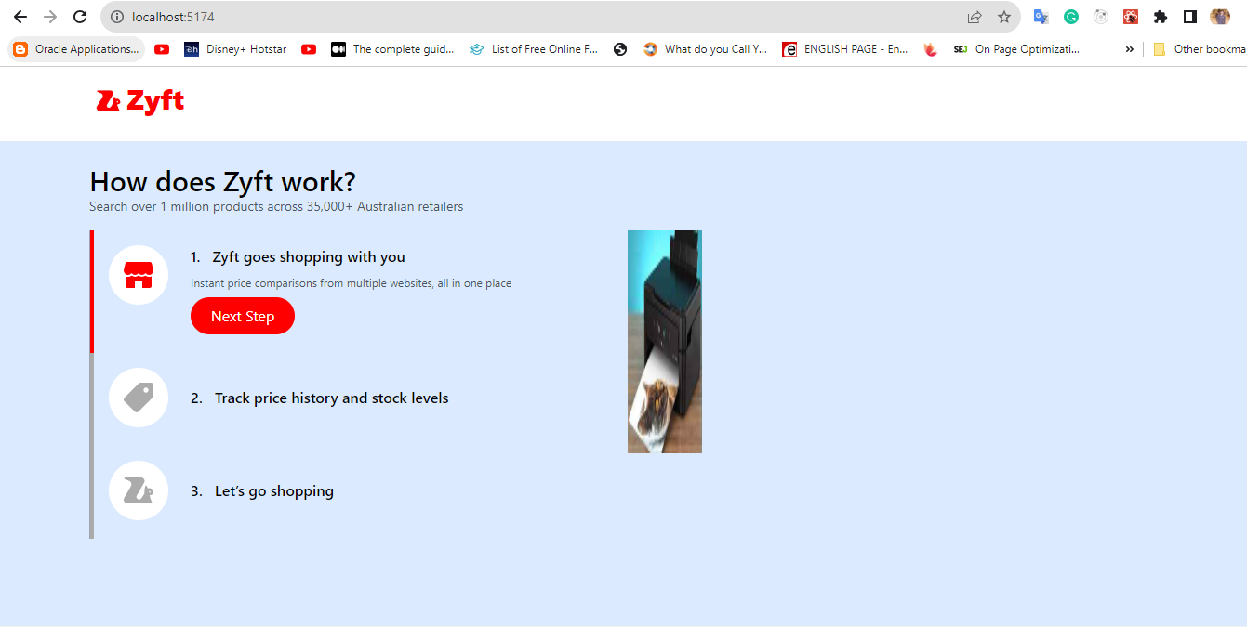

Functionality is pretty much as <https://zyft.com/getting-started/>

We can click Next Step to navigate to step 2 or we can directly click on Step2

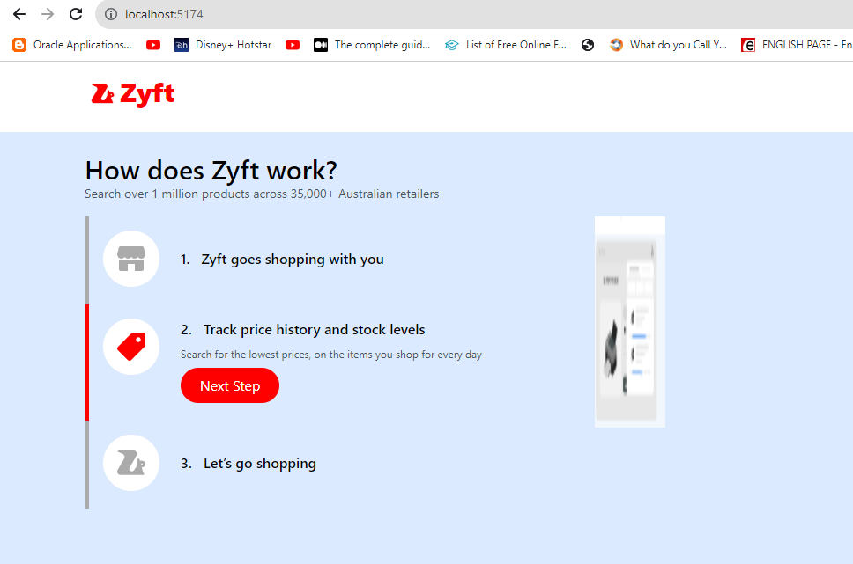

Similarly for step 3

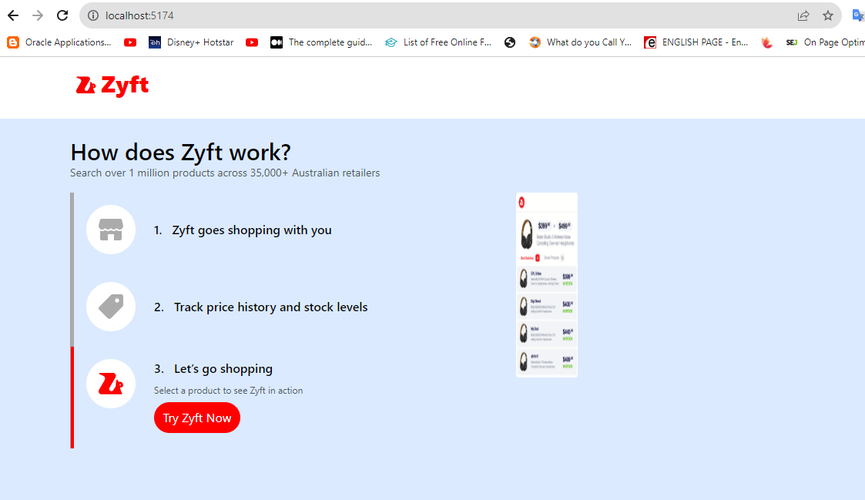

In Step 3 when we click on Try Zift Now button, it will open a new window pointing to

https://ozdingo.com.au/products/comfee-rangehood-900mm-stainless-steel-kitchen-canopy-filter-replacement-x2

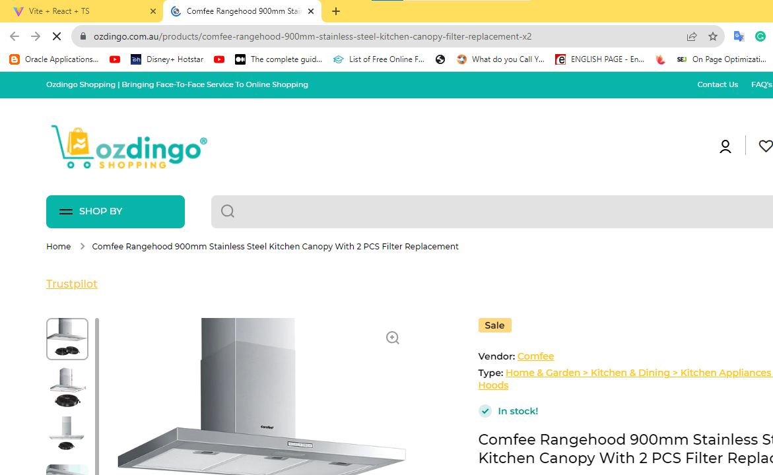

Task2: Tag the Model Number in html pages

Beneath the Task 1, we can see the below Task2

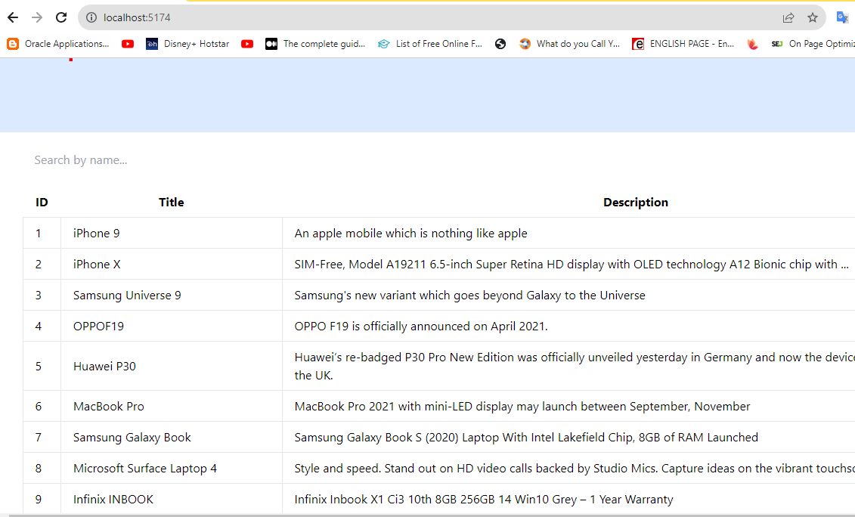

This was developed using React + Typescript

Output of the function should be start and end indexes of the model number in html

Let’s take an example

Starting letter I, ending letter r

We just enter **i**xxxr

Expected result: All the items starting with letter I and ending with letter R

